|

Temple Inn&Suites

Site Plan

**Giselle Araujo**

**CIT 230 – Br. Odom**

**Site Name**

This site is going to be called **TempleInn&Suites.com**.

**Overview**

**Site Purpose**

The purpose of this web site is to provide information about all the services that the hotel chain offers to its patrons. These patrons are those who come to serve in the temple, they participate in temple events, such as sealings and other kind ordinances and receptions and youth trips.

**Target Audience**

## The audience to the TempleInn&Suites.com are those who are looking for specialized services that the hotel chain offers to those who travel long distances to serve in the temples.

**Who:**  Members of the church that travel long distances to serve in the temples.

**Age:** 12 to 100

**Technology:** Internet

**Income:** between $30,000 and above annually.

**Motivation:** Have a place to stay during the days of temple work.

**Personas**

Neil Handmake

**Occupation: Retired**

**Demographics and Education:** 70 years old. He is business manager retired.

**Goals and motivation for using the site:** To make a hotel reservation and see temple information.

**Social:** He likes to have time with his family, loves to serve in the temples, he likes to learn new cultures.

**Technology:** Uses mostly his iPhone, and his MacBook. Uses mostly Microsoft Office software (Word, Outlook, Excel, PowerPoint).

Samantha Smith

**Occupation:** Student

**Demographics and Education:** 22 years old. She is an educational Student.

**Goals and motivation for using the site:** To make a hotel reservation and see temple information, as she goes to the temple every 2 weeks, she prefers to stay in a hotel close to the temple.

**Social:** She loves to make new friends, she loves swimming, sing and go out with family members and friends.

**Technology:** Uses iPhone, and she also has an Intel laptop, which she uses to study. Uses Microsoft Office software (Word, Outlook, Excel, PowerPoint).

**Color Palette**

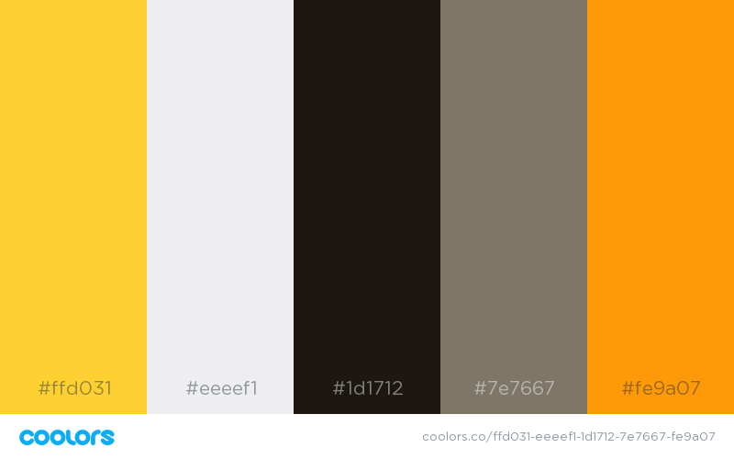

|  |  |  |
| --- | --- | --- |
| **Primary** | **Secondary** | **Accent** |
| #fe9a07  #7e7667 | #1d1712  # eeeef1 | #ffd031 |

## Background

## Text

**Accent(s), highlights** 

Typography

### Page Title

### 

### This font is universal: It can be used in logos, headlines, and for text. It is an open Sans.

### Heading Font

### 

### The Amaranth family is a friendly upright italic design with a slight contrast and distinctive curves.

### 20 px

### Paragraph

### 

### Sarabun is an open source multi-script webfont. Source Sans Pro.

**16 px**

**Site Map**

### **Wireframe Sketches**

### 

### Desktop

### 

### Medium view

### 

### Small view

­